Software Requirements Specification

for

Smart Automatic Stock System: Stock Sync
Version 1.0 approved
Prepared by Group 18
Giovanni August, Nicholas Wilson, Michael Owen
BINUS University
25 February 2026
Table of Contents
1. Introduction 1
1.1 Purpose 1
1.2 Document Conventions 1
1.3 Intended Audience and Reading Suggestions 1
1.4 Product Scope 1
1.5 References 3
2. Overall Description n3
2.1 Product Perspective 3
2.2 Product Functions 3
2.3 User Classes and Characteristics 3
2.4 Operating Environment 3
2.5 Design and Implementation Constraints 3
2.6 User Documentation 4
2.7 Assumptions and Dependencies 4
3. External Interface Requirements 4
3.1 User Interfaces 4
3.2 Hardware Interfaces 4
3.3 Software Interfaces 4
3.4 Communications Interfaces 5
4. System Features 5
4.1 System Feature 1 5
4.2 System Feature 2 (and so on) 6
5. Other Nonfunctional Requirements 6
5.1 Performance Requirements 6
5.2 Safety Requirements 6
5.3 Security Requirements 6
5.4 Software Quality Attributes 6
5.5 Business Rules 6
6. Other Requirements 7

Revision History
Name | Date | Reason For Changes | Version
Group 18 | 25/02/26 | Progress Chapter 1 content according to team discussion | 1.0
 | 8/03/26 | Progress Chapter 2 | 1.1
 | 27/03/26 | Progress until Diagram Creations (Chapter 7) | 1.2
 | 29/04/26 | Progress Chapter 8 | 1.3

Introduction

Purpose
This Software Requirements Specification (SRS) serves to describe the functional and non-functional requirements for the Smart Automatic Stock System, also known as Stock Sync. This document provides a comprehensive description of the system's expected behavior, features, and interfaces to support its development, testing, and deployment activities. As the specified product is a working prototype that covers the functionality of an inventory management system using barcode scanning, the SRS will also mention features needed to be included and features that will just act as a simulation within the product. The document serves as a reference for stakeholders such as developers and the project manager to ensure a shared understanding of system requirements and project scope.

Document Conventions
High-level functioning requirements should always be identified with a unique ID. It is assumed that any priority assigned to a parent requirement is automatically inherited by its detailed sub-requirements. Within the text, all User Interface Elements (such as buttons or menu items) must be bolded, while User Roles, such as Staff or Admin, should be italicized. These conventions are designed to ensure that all developers and testers can quickly scan the document for actionable technical details without misinterpretation of the hierarchy of needs.

Intended Audience and Reading Suggestions ?
This document is intended for the following stakeholders:
Stakeholder | Role
Project Manager (Lecturer) | Acts as the project manager and evaluator who reviews, validates, and approves system requirements and overall project direction.
Development Team (Group 18) | Responsible for designing, implementing, and integrating the Stock Sync prototype according to the specified requirements.

Product Scope
The Stock Sync Smart Automatic Stock System will be developed as a mobile-optimized web application, with the intent of being a functional prototype that demonstrates the workflow and user interface of a modern, barcode-driven inventory management platform. The system aims to simulate a real-world stock management service by allowing user interactions such as scanning item barcodes to check stock levels, adding items to storage, and deducting items upon sale within a controlled prototype environment.

Stock Sync is intended primarily for academic and demonstration purposes, providing a realistic representation of stock checking and adjustment processes without integrating actual enterprise resource planning (ERP) infrastructure. The prototype supports usability evaluation, requirement validation, and interaction design exploration for automated stock systems.
In Scope
Features or systems that are within the product’s scope are as follows:
- User Interface Module: A responsive, mobile-friendly interface enabling users to navigate the system, scan items, and perform stock adjustments quickly.
- Barcode Scanning Integration: Functionality to capture barcode inputs (via device camera or simulated input) to instantly identify product details and current stock levels.
- Inventory Catalog Management: Display of product details including names, descriptions, images, and current available quantities.
- Stock Adjustment Module: Interactive interface allowing Staff accounts to manually or automatically (via scan) increase or decrease stock levels representing inward shipments or outward sales.
- Basic User Account Features: Simple user registration and login for both staff and admin accounts.
- Administrative Content Management: Basic interface for adding new products, generating barcodes, and managing system users.
- Backend / Database Layer: Storage of prototype data such as users, product details, stock levels, and transaction logs using local or lightweight database solutions.
Out of Scope
As Stock Sync is intended as an interface prototype, the following features are excluded from this phase of the project:
- Integration with real-world financial systems, point-of-sale (POS) systems, or third-party enterprise ERP platforms.
- Implementation of multi-location warehouse management with complex inter-store logistics.
- Advanced security mechanisms beyond basic authentication.
- Native Mobile application development.

References
You may use your own references ya

Overall Description

Product Perspective
Stock Sync is a new, self-contained working prototype designed to demonstrate the workflow of a modern, barcode-driven inventory management platform. While it simulates real-world stock management, it is intended primarily for academic and demonstration purposes rather than as a component of a larger enterprise resource planning (ERP) infrastructure. The system originates from a university project requirement to explore interaction design and requirement validation for automated stock systems.

Product Functions
The major functions of the Stock Sync system include:
User Authentication: Allowing Staff and Admin to securely register and log in.
Barcode Scanning: Capturing barcode inputs via device camera to identify products and display stock levels.
Inventory Catalog Management: Providing a detailed view of products, including names, images, and quantities.
Stock Adjustment: Enabling users to manually or automatically increase or decrease stock levels to reflect shipments or sales.
Administrative Management: Tools for adding new products, generating barcodes, and managing user accounts.

User Classes and Characteristics
The system identifies two primary user classes:
Staff: The most frequent users of the system. They are responsible for day-to-day operations such as scanning barcodes and performing stock adjustments.
Admin: Users with higher privilege levels who manage the system's content, including product catalogs, barcode generation, and user account oversight.

Operating Environment
Stock Sync will operate as a mobile-optimized web application. It is designed to run in modern web browsers on mobile devices to facilitate on-the-go barcode scanning. The backend involves a database layer utilizing local or lightweight database solutions to store user and transaction data

Design and Implementation Constraints
Technical Stack: The prototype is limited to a web-based interface; native mobile application development is currently out of scope.
Data Handling: Stock adjustments and transaction logs must be stored in a lightweight or local database.
Connectivity: The system requires an active network connection to sync stock data between the interface and the database layer.
Documentation Conventions: High-level requirements must be identified with a unique ID, and UI elements must be bolded in all technical documentation.

User Documentation
The project will deliver the following documentation components:
Software Requirements Specification (SRS): This document, detailing all functional and non-functional needs.
User Interface Specification: A separate document containing detailed UI designs and screen layouts.
Prototype Simulation Guide: Documentation explaining which features are fully functional and which act as simulations within the prototype environment

Assumptions and Dependencies
Hardware Availability: It is assumed that users will have access to a device with a functioning camera for barcode scanning features.
Scope Limitation: It is assumed that the system does not need to integrate with real-world financial or POS systems for this phase.
Inheritance of Priority: It is assumed that any priority assigned to a parent requirement is automatically inherited by its sub-requirements

External Interface Requirements

User Interfaces
The logical characteristics of the user interface for Stock Sync are defined by its requirement to function as a mobile-optimized web application. Because Staff will be using the application on the warehouse floor, the UI must prioritize speed, one-handed operation, and high visibility.
GUI Standards and Product Style Guides
- Design Language: The interface shall adhere to Google's Material Design 3 standards for web to ensure a native-app feel on mobile browsers.
- Color Palette: The system will use a high-contrast palette. Primary actions (e.g., Scan Barcode, Confirm Adjustment) will utilize a primary brand color (e.g., Deep Blue), while destructive or negative actions (e.g., Delete Item, Decrease Stock) will utilize standard alert colors (e.g., Crimson Red).
- Typography: Sans-serif fonts (e.g., Roboto or Inter) must be used globally for legibility at various screen sizes.
Screen Layout Constraints
- Mobile-First Viewport: All interfaces must be constrained to a vertical, mobile-first aspect ratio (minimum 320px width), utilizing responsive CSS flexbox/grid layouts to scale up to tablet sizes if necessary.
- Navigation: The system shall implement a persistent Bottom Navigation Bar for Staff (containing tabs for Home/Dashboard, Scan, and Catalog) to allow easy thumb-reach on mobile devices.
- Safe Areas: Critical buttons and input fields must be placed within the "thumb zone" (the lower half of the screen) and avoid the top/bottom safe areas reserved for the device's OS status bars.
Standard Buttons and Functions
- Global Help: A subtle "?" (Help) icon shall appear in the top-right header of every screen, triggering a modal with contextual instructions for the current page.
- Input Controls: Numeric inputs for stock adjustments must feature large, easily tappable "+" and "-" stepper buttons alongside the manual text input field.
Error Message Display Standards
- System errors, validation failures (e.g., "Item Not Found"), and success states (e.g., "Stock Updated") shall not use intrusive pop-up alerts.
- Instead, they must be displayed as Toast Notifications at the bottom of the screen that auto-dismiss after 3 seconds.
  - Success: Green background with a checkmark icon.
  - Error/Warning: Red background with an alert icon.
Software Components Requiring a UI
- Authentication Module: Login and Registration screens.
- Dashboard: The landing page displaying quick stats and the primary "Scan" call-to-action.
- Camera Scanner Modal: A full-screen overlay activating the device camera with a targeting reticle.
- Product Detail & Adjustment View: The screen displaying the scanned item's data and the UI controls to change stock quantities.
- Admin Management Console: A slightly denser, table-based interface for managing the product catalog and user accounts.

Hardware Interfaces
Because Stock Sync is designed as a mobile-optimized web application, it does not require proprietary external hardware (such as dedicated point-of-sale laser scanners or RFID readers). Instead, the software interfaces directly with the host device's built-in physical components through standard web APIs.
Supported Device Types The system is designed to operate on consumer-grade mobile devices.
- Form Factors: Smartphones and tablets.
- Minimum Hardware Specifications: * Camera: A rear-facing camera module with autofocus functionality and a minimum resolution of 5 Megapixels. Autofocus is a strict hardware requirement to ensure the software can parse barcodes accurately in variable warehouse lighting.
  - Connectivity: An active Wi-Fi receiver or Cellular (3G/4G/5G) radio module.
Camera Interface (Primary Interaction)
- Logical and Physical Characteristics: The software interfaces with the physical optical sensor of the host device. Logically, this connection is bridged via the HTML5 MediaDevices.getUserMedia() API, which allows the browser to request direct access to the hardware's video stream.
- Data and Control Interactions: * Control: When a Staff user triggers the scanning module, the software sends a control request to the device operating system to power on the rear camera and (if supported by the browser) activate the physical LED flashlight for illumination.
  - Data: The hardware feeds a continuous stream of video frames to the client-side web application. The software's JavaScript execution environment utilizes the device's CPU to process this visual data locally, searching for barcode patterns. Once a barcode is resolved, the video stream data is discarded, and only the resulting alphanumeric string is retained.
Network Interface
- Logical and Physical Characteristics: The application relies on the host device's physical Network Interface Card (NIC) or cellular modem to communicate with the remote database server.
- Communication Protocols: All data interactions routed through the physical network hardware (such as sending a scanned barcode string to the database or receiving updated stock quantities) shall be transmitted via HTTP/1.1 or HTTP/2 protocols. To ensure data integrity and security over potentially public warehouse Wi-Fi networks, all hardware network communications must be encrypted using HTTPS (TLS 1.2 or higher).

Software Interfaces
The Stock Sync prototype will utilize a modern web stack to ensure responsiveness and rapid development.

Frontend Interface: The client-side application will be built using a modern JavaScript framework (e.g., React.js or Vue.js) to handle state management (like keeping track of scanned items before committing them to the database).

Backend / API Layer: The frontend will communicate with a lightweight backend service (e.g., Node.js with Express) that handles business logic and routes requests.

Database Management System (DBMS): Given the relational nature of inventory (Products -> Transactions -> Users), the system will interface with a relational database (e.g., MySQL or PostgreSQL).

Data Exchange: All data shared between the frontend client and the backend server must be formatted as JSON (JavaScript Object Notation).

Communications Interfaces
Protocol: All client-server communication shall occur over HTTPS (HTTP Secure) to prevent basic packet sniffing on public warehouse networks.

Architecture: The system will use a RESTful API architecture. Standard HTTP methods must be used logically: GET for fetching catalog data, POST for adding new products or transaction logs, PUT/PATCH for updating stock quantities, and DELETE for removing catalog items.

System Features
This section outlines the core functional requirements of the Stock Sync prototype, categorized by the major services provided by the platform.

Barcode Scanning & Resolution
4.1.1 Description and Priority
Priority: High. This is the core functionality of the prototype. The system uses the device camera to read a physical barcode, parse the string, and query the database for the matching product.
4.1.2 Stimulus/Response Sequences
Stimulus: Staff user taps the Scan button on the dashboard.

System Response: System requests camera permissions from the browser and opens the camera overlay.

Stimulus: User aligns a barcode within the targeting reticle.

System Response: System parses the barcode into an alphanumeric string, closes the camera overlay, and sends a GET request to the API.

System Response: If the item exists in the database, the UI routes to the "Product Detail & Adjustment" view. If it does not exist, the UI triggers an "Item Not Found" Toast notification and returns the user to the dashboard.
4.1.3 Functional Requirements
REQ-1.1: The system shall utilize the HTML5 MediaDevices API to access the host device's rear-facing camera.

REQ-1.2: The system shall decode standard 1D barcodes into a text string within 2 seconds of visual acquisition.

REQ-1.3: Upon successful decode, the system shall query the backend database for a product catalog record matching the decoded string.

REQ-1.4: If the query returns a 404 Not Found error, the system shall display a red Toast notification stating "Barcode not recognized in catalog" and reset the scanner module.

Stock Adjustment (CRUD Operations)
4.2.1 Description and Priority
Priority: High. Allows Staff to manually increment or decrement the available quantity of a scanned item to simulate inbound shipments or outbound sales.
4.2.2 Stimulus/Response Sequences
Stimulus: On the Product Detail view, the Staff user taps the + or - stepper buttons, or manually types a numeric value into the adjustment input field.

Stimulus: User taps Confirm Adjustment.

System Response: The system validates the input, sends a PATCH request to the database to update the total stock, and creates a record in the transaction log.

System Response: The UI displays a green Toast notification ("Stock Updated Successfully") and refreshes the current stock display.
4.2.3 Functional Requirements
REQ-2.1: The system shall enforce input validation on the stock adjustment field, strictly preventing the entry of special characters, decimals, or letters.

REQ-2.2: The system shall prevent "Negative Stock" states. If a decrement operation would result in a stock level below zero, the UI must disable the Confirm button and display a local warning.

REQ-2.3: Every successful stock adjustment must automatically generate an immutable transaction log entry containing: User ID, Product ID, Timestamp, Adjustment Amount, and the New Total Stock.

Authentication & Role Authorization
4.3.1 Description and Priority
Priority: High. The system must authenticate users to track who is making stock adjustments and restrict sensitive actions to Admin accounts.
4.3.2 Stimulus/Response Sequences
Stimulus: User navigates to the StockSync web application and enters their credentials on the Login screen.

System Response: The system sends a POST request to the authentication endpoint.

System Response: If credentials are valid, the server returns an authentication token (e.g., JWT) with the user's assigned role. The UI redirects the user to the Dashboard.

System Response: If credentials are invalid, the UI displays an error Toast ("Invalid email or password") and clears the password field.

Stimulus: A Staff user attempts to manually navigate to an Admin-only URL.

System Response: The UI router intercepts the request, denies access, and redirects the user back to the standard Dashboard.
4.3.3 Functional Requirements
REQ-3.1: The system shall authenticate users via a secure email and password combination.

REQ-3.2: Passwords must not be stored in plaintext; the backend must securely hash passwords before storing them in the database.

REQ-3.3: The system shall support exactly two distinct user roles: Staff (read catalog, update stock) and Admin (full CRUD access to catalog and users).

REQ-3.4: The system shall enforce Role-Based Access Control (RBAC) on both the client-side UI (hiding Admin elements from Staff) and the backend API (rejecting unauthorized API calls).

Administrative Catalog Management
4.4.1 Description and Priority
Priority: Medium. Admin users need a dedicated interface to populate the database with new products, assign barcodes, and manage the master inventory list.
4.4.2 Stimulus/Response Sequences
Stimulus: Admin navigates to the "Manage Catalog" view and clicks Add New Product.

System Response: The UI displays a form requesting: Product Name, Description, Base Price, Initial Stock Quantity, and an option to either manually enter a Barcode String or auto-generate one.

Stimulus: Admin fills out the form and clicks Save Product.

System Response: The frontend validates that required fields are not empty and sends a POST request to the backend.

System Response: The backend checks if the barcode string is unique. If unique, it creates the database record and returns a success status. The UI displays a green Toast and adds the item to the catalog list.

System Response: If the barcode string already exists in the system, the backend returns a 409 Conflict error. The UI highlights the barcode input field in red and displays "Barcode already assigned to another product."
4.4.3 Functional Requirements
REQ-4.1: The system shall provide a form for Admin users to input new product data, enforcing mandatory fields.

REQ-4.2: The system shall ensure every Barcode String in the database is strictly unique.

REQ-4.3: The system shall include an "Auto-Generate Barcode" utility that creates a random, unique 12-digit numeric string for products that do not have a pre-existing manufacturer barcode.

REQ-4.4: The system shall allow Admin users to perform soft deletes (archiving) on products, hiding them from the Staff view without destroying historical transaction data linked to that product.

Other Nonfunctional Requirements

Performance Requirements
API Latency: All REST API responses for stock queries and CRUD operations must complete within 500 milliseconds under normal load to prevent user bottlenecking on the warehouse floor.

Scanner Initialization: The MediaDevices camera feed must initialize and render the video stream to the UI within 1.5 seconds of the user tapping the "Scan" button.

Resolution Speed: The client-side barcode parsing algorithm must resolve a clear 1D barcode within 1.0 second of visual acquisition.

Application Load Time: The initial web application payload (HTML/CSS/JS) must be under 2MB to ensure a load time of less than 3 seconds on standard 4G mobile networks.

Safety Requirements
Hardware Resource Management: The application must explicitly release the camera hardware lock (stopping the video track) immediately after a barcode is resolved or the modal is closed. Continuous background polling of the camera must be prevented to avoid severe device overheating and battery degradation.

Security Requirements
Encryption in Transit: All client-server communications must be encrypted using TLS 1.2 or higher (HTTPS). Requests made over unencrypted HTTP must be forcefully redirected or rejected.

Authentication Mechanism: User sessions must be managed using JSON Web Tokens (JWT). Tokens must have a strict expiration time of 12 hours to ensure unattended warehouse devices do not maintain persistent administrative access.

Password Cryptography: User passwords must never be logged or stored in plaintext. The backend must hash all passwords using the bcrypt algorithm with a minimum of 10 salt rounds.

Injection Prevention: All database queries must utilize parameterized statements or a secure Object-Relational Mapper (ORM) to completely mitigate SQL Injection vulnerabilities.

Software Quality Attributes
Usability (Accessibility): Because the app is used in variable warehouse lighting, the UI must maintain a minimum contrast ratio of 4.5:1 for all text against its background (WCAG AA standard). Touch targets (buttons) must be a minimum of 48x48 CSS pixels to accommodate users operating the device with one hand or wearing gloves.

Reliability (Fault Tolerance): If the client device temporarily loses network connectivity, the UI must gracefully disable the "Scan" and "Update" buttons and display a "Network Offline" warning, rather than allowing the user to scan items that cannot be synchronized with the database.

Business Rules
Rule 1 - The Zero-Floor Rule: Total stock quantities cannot be negative. The system must physically block any decrement transaction that results in a sub-zero value.

Rule 2 - Immutability of History: Transaction logs (records of stock adjustments) are append-only. Once a stock update is committed, the resulting log entry cannot be edited or deleted by any user, including Admins. Errors must be corrected by creating a new, offsetting transaction.

Rule 3 - Soft Deletion: Products cannot be hard-deleted from the database if they possess a transaction history. They must be flagged as is_archived = true to preserve historical data integrity.

Other Requirements

Database Requirements
Relational Structure: The system requires a relational database (e.g., MySQL 8.0+ or PostgreSQL 13+) to enforce referential integrity between Users, Products, and Transaction Logs.

Local Prototyping: For the purposes of the academic prototype demonstration, the database may be hosted locally (e.g., via Docker or XAMPP) or on a lightweight free-tier cloud instance (e.g., Supabase or a managed AWS RDS micro instance).

Browser Support
The application must support the latest two versions of major mobile web browsers: Google Chrome for Android and Apple Safari for iOS, specifically ensuring compatibility with their respective WebRTC and MediaDevices API implementations.

Appendix A: Glossary
CRUD: Create, Read, Update, Delete. The four basic operations of persistent storage.

JWT: JSON Web Token. A compact, URL-safe means of representing claims to be transferred between two parties, used here for session authorization.

RBAC: Role-Based Access Control. Restricting system access to authorized users based on their assigned roles (Staff vs. Admin).

MediaDevices API: A web standard interface that provides access to connected media input devices like cameras and microphones.

Unified Modeling Languages

Use Case Diagram
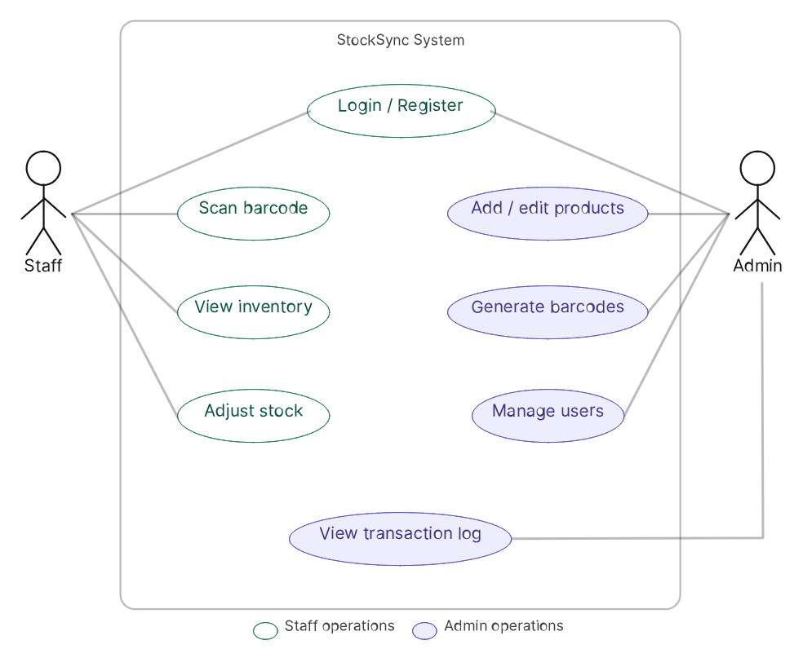

Activity Diagram
4.2.1 User Authentication
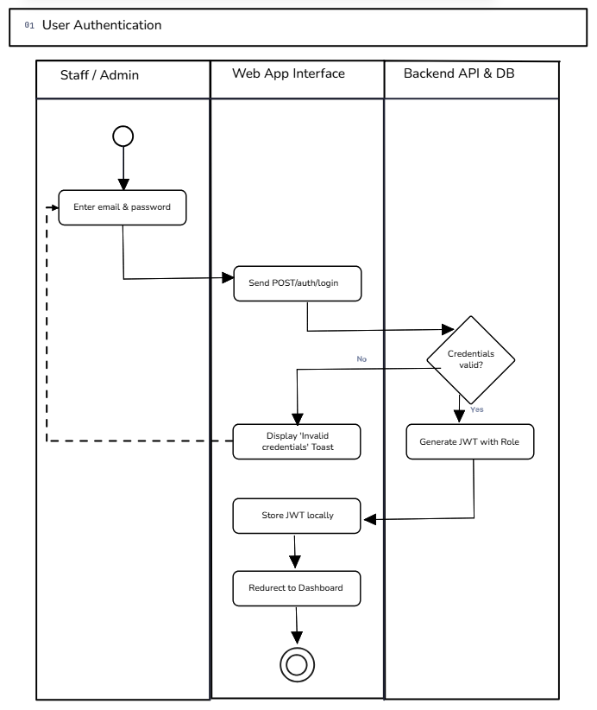
4.2.2 Barcode Scan
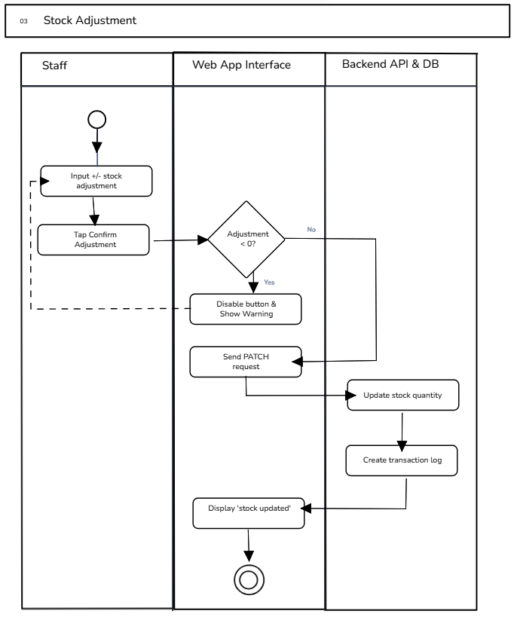
4.2.3 Stock Adjustment

4.2.4 Add New Product
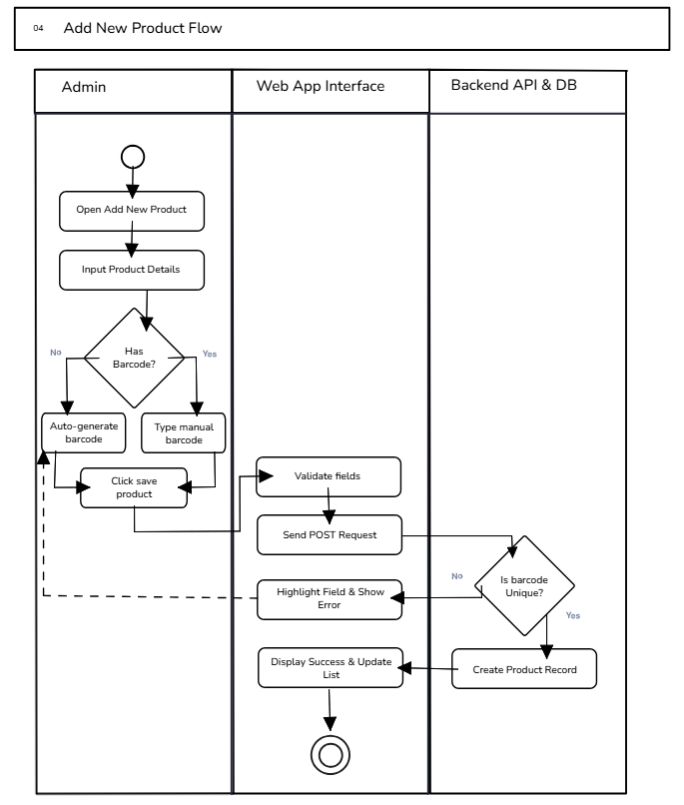

Entity Relationship Diagram
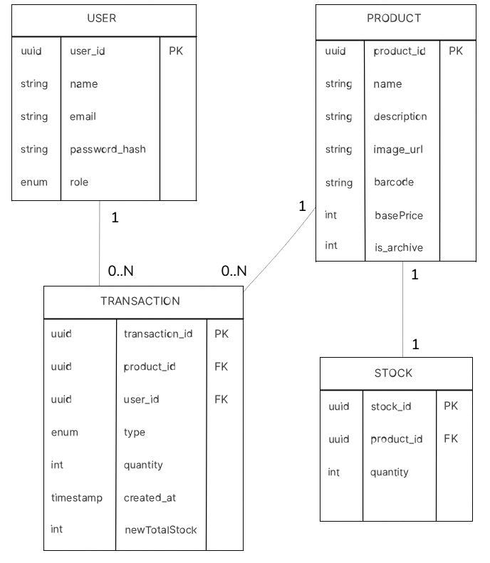

Class Diagram
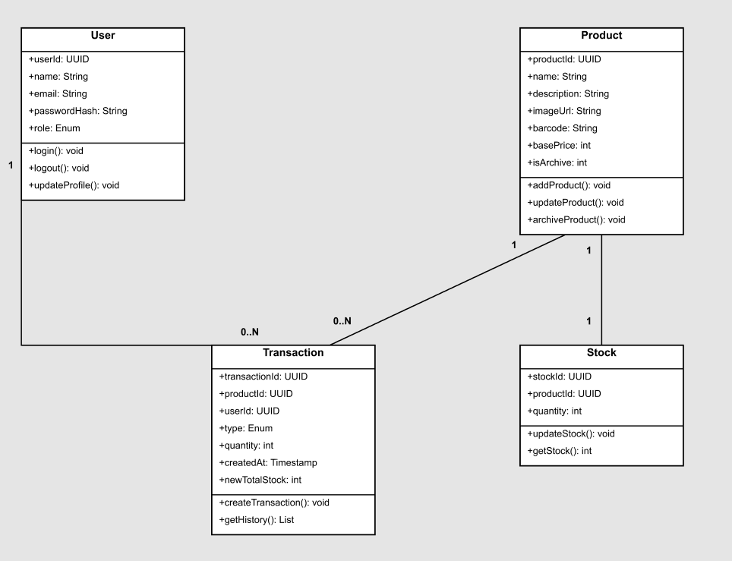

Sequence Diagram
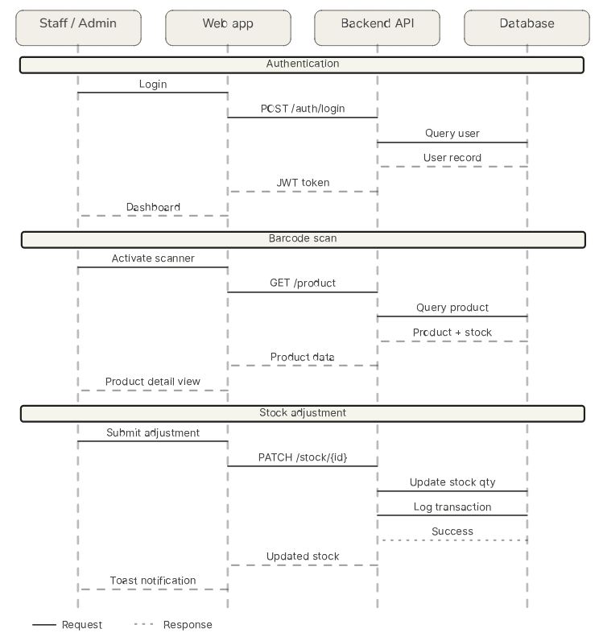

Prototype
Link Figma: https://www.figma.com/design/cWLVydgCuXZhwc2HiWnEDi/Figma-SE?node-id=4-1147&t=vHBXh5FPIytnbIzo-1

Pages Design:
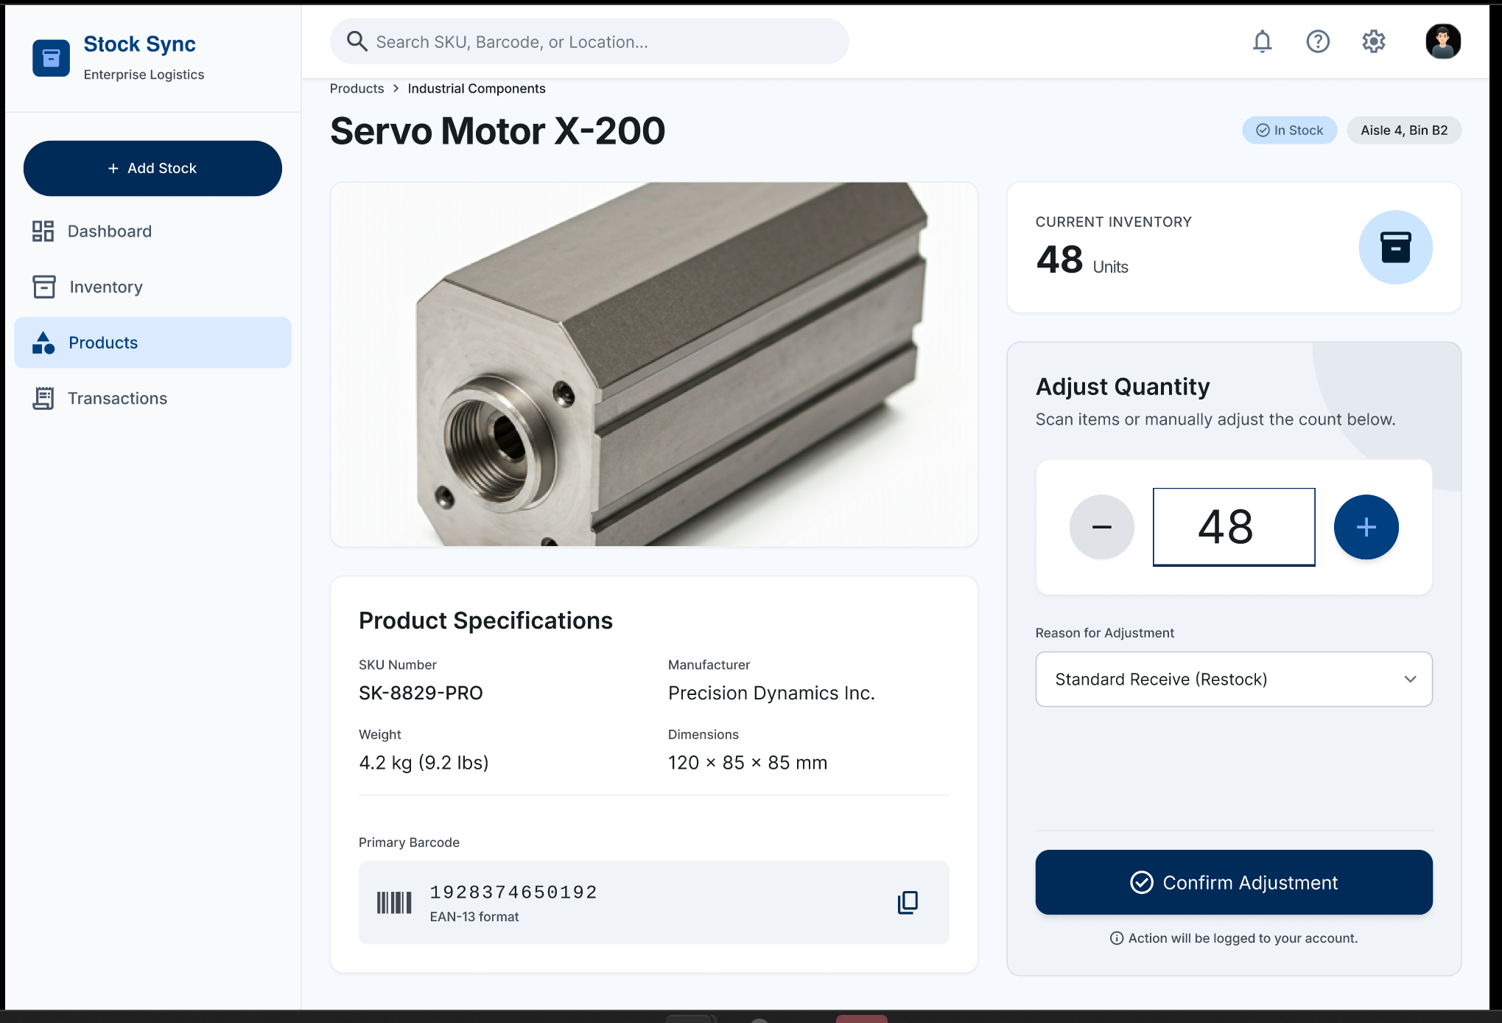
Product Detail Page: This page gives warehouse staff a deep dive into a specific item in this case the "Servo Motor X-200" showing everything they'd need to know at a glance: current inventory count (48 units), exact shelf location (Aisle 4, Bin B2), full product specs like SKU, weight, dimensions, and manufacturer, plus the primary barcode for scanning. The real workhorse of this page is the Adjust Quantity panel on the right, where staff can manually increment or decrement the stock count, select a reason for the adjustment (e.g. restock, damage, audit correction), and confirm the changes, which gets logged to their account for accountability.
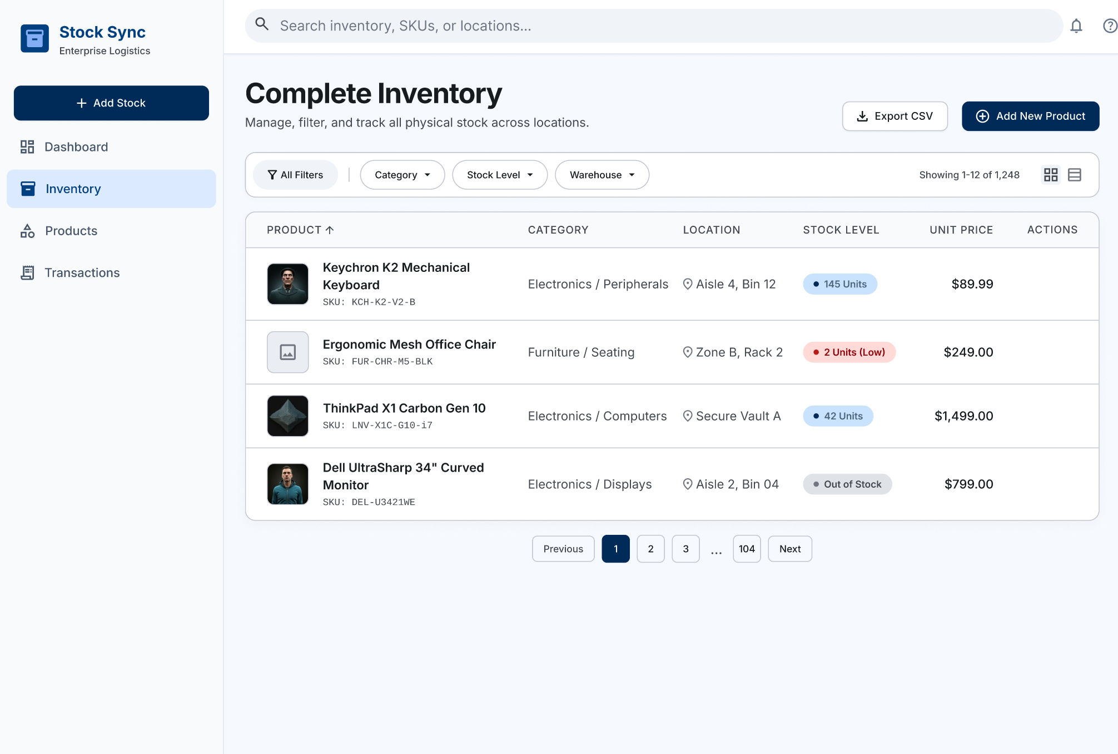
Complete Inventory Page: This is the bird's-eye view of everything. The warehouse holds all 1,248 products across every location, presented as a scannable table showing each product's name, SKU, category, physical location, stock level status, and unit price. Stock level badges give instant visual triage: healthy stock shows in blue, low stock pops in red ("2 Units (Low)"), and depleted items are flagged as "Out of Stock" in gray, so managers can prioritize restocking at a glance. The filter bar at the top lets users slice the list by category, stock level, or warehouse, and the Export CSV and Add New Product buttons support bulk data workflows and onboarding new items into the system.

